 

TIBCO BWCE with Docker

Version 1.0

By

Goutham Jayaram

Contents

Setup TIBCO BWCE for Docker 3

Setting up Docker on Linux and Create BWCE Base image 5

Create WeatherApp image and Run as Docker container 6

# Setup TIBCO BWCE for Docker

1. Add the below property in config.ini file of BusinessStudio present at

\BWCE_HOME\studio\4.0\eclipse\configuration

ContainerTarget=Docker

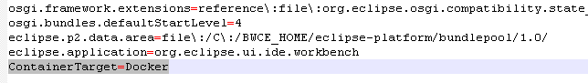

1. In BusinessStudio, go to Window 🡪 Preferences 🡪 BusinessWorks Container Edition 🡪 Container Platform.

Select the platform as Docker.

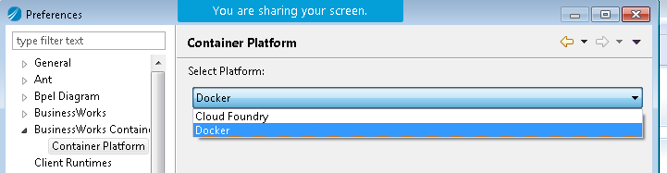

1. Restart the BusinessStudio.
2. Create your application in BWCE

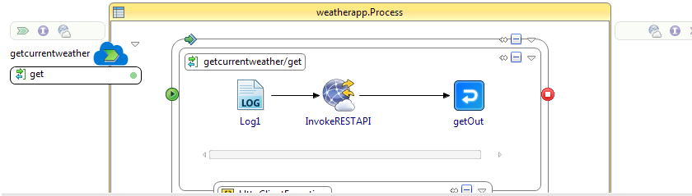

1. Create EAR of the application.

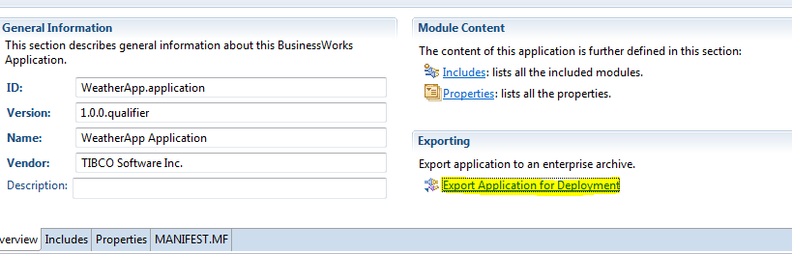

WeatherApp.application_1.0.0.ear is created.

# 

# Setting up Docker on Linux and Create BWCE Base image

1. Install Docker.
2. Create TIBCO BWCE base image with below steps. Note that base image can be created only in linux OS.
3. Download bwce_cf.zip and place it in a temp path: /tempdir/bwce_cf.zip
4. Clone the following github repo on the linux box - <https://github.com/TIBCOSoftware/bwce-docker>
5. Create the BWCE base image by running the following script:

./createDockerImage.sh /tempdir/bwce_cf.zip Tibco/bwce:latest

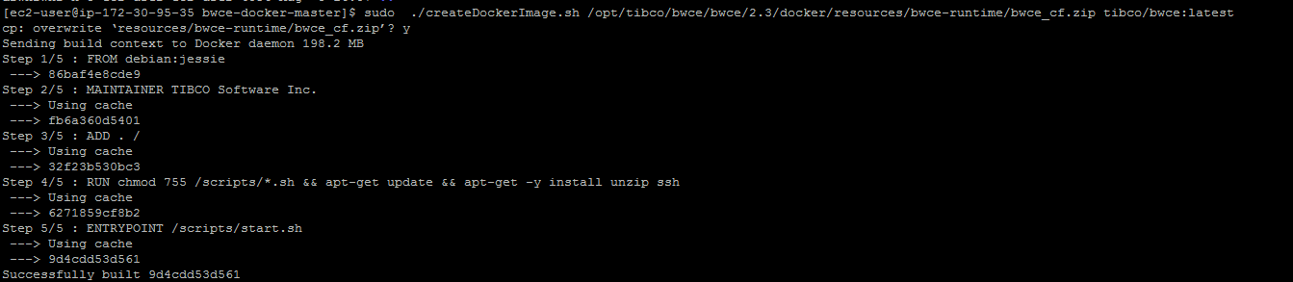

1. TIBCO BWCE base image is created:

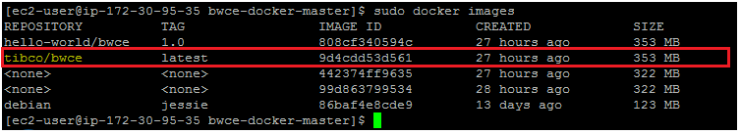

# Create WeatherApp image and Run as Docker container

1. Create the application image of your EAR file based on the BWCE base image created in #2c.
2. Copy the application EAR into a temp dir and create a Dockerfile in the below format.

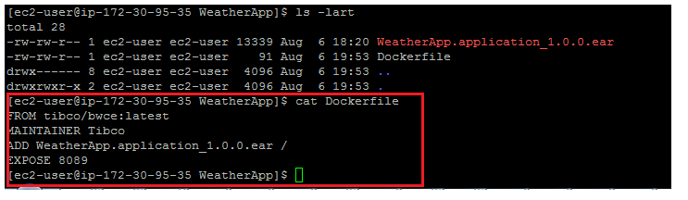

1. Run the following command from the same folder where EAR file and Dockerfile are present.

sudo docker build -t weatherapp/bwce:1.0 .

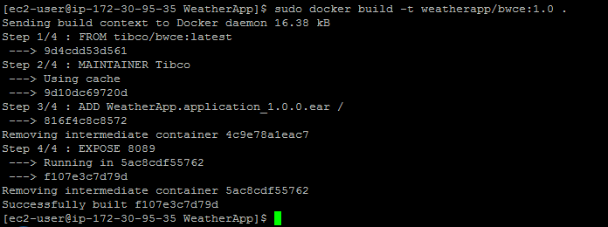

1. Check for the weatherapp image with below command:

Sudo docker images

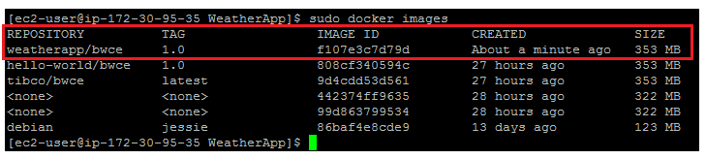

Now the application is ready to be run as a container in Docker.

1. Follow the below steps to start the application as docker container and test:
2. Execute the below command to run the WeatherApp image:

sudo docker run --name "WeatherApp" -p 8089:8089 -d weatherapp/bwce:1.0



1. Check if the WeatherApp container is now running: sudo docker ps -a

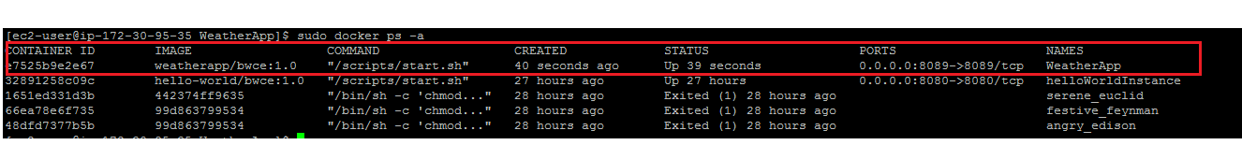

1. Test your application: